Guide to Running RatASM with Cygwin “Portable”
- Place the file ratasm_with_cygwin.zip in a convenient directory in your computer. Unzip this file to find the directory “ratasm”. This directory contains a subdirectory titled “cygwin” which contains all required Cygwin .dll files required for operation of ratasm2.exe. A good location to install this directory is in the root of the C drive. Everything required to run Ratasm2.exe is included in this zip file and it is not necessary to install Cygwin.
- Start a command prompt.
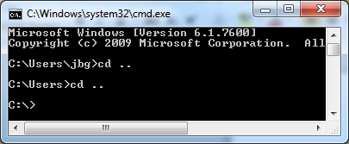
Here are some handy Windows command prompt commands:
CD .. | Move up a directory level
CD ratasm | Change directories from the current directory into the ratasm directory
C: | Switch to C drive
Del test.asm | Delete the file test.asm from the current directory

- Ensure that the PATH variable (one of the environment variables) on your computer includes the path to the new location where the Cygwin files are installed. This can easily be done with the following command prompt entry.
Path=c:\ratasm\cygwin
- Write your assembly file and name it with a .asm suffix. An example name would Exp1.asm.
- Assemble your program by typing ratasm2.exe followed by your assembly file at the command line. An example command line entry to assemble is:
ratasm2.exe exp1.asm > more
- RatASM should generate a prog_rom.vhd file which is easily viewed in a Xilinx edit window.

